AP Calc WS# 7 Limits and Continuity Test Review Name: ____________

Part A The use of a calculator is not allowed.

Find the limits of the following:

1. 2.

3. 4.

5. 6.

7. 8.

9. If find

10. 11.

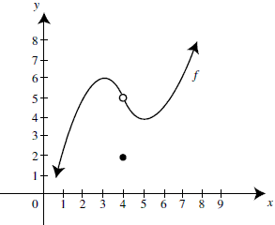12. The graph of a function *f* is shown .

Which of the following statements is/are true?

a. $\lim_{x→4^{-.}}f(x)=5$

b.

c. f(4) = 5

d.

13. Find the value of a so that the function is continuous



Part B Calculators are allowed.

13. Find the horizontal and vertical asymptotes of the graph of the function

14. Find the limit $\lim_{x→5^{+.}}\frac{5+[x]}{5-x}$ when [x] is the greatest integer of x

15. Find the points of discontinuity of the function

16. For what value of k is the function $g(x)=\left\{\begin{aligned}x^{2}+5x≤3 \\ 2x-kx>3\end{aligned}\right\}$ continuous at x = 3

17. Determine if $f(x)=\left\{\begin{aligned}\frac{x^{2}+5x-14}{x-2} if x≠2 \\ 12 if x=2\end{aligned}\right\}$ is continuous at x =2. Explain why or why not.

18. Given f(x) as shown, find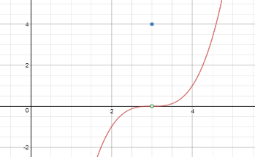

* 1. f (3) b.

c. d.

e. Is f(x) continuous at x =3? Explain

19. A function f is continuous on [–2, 2] and some of the values of f are shown below:

|  |  |  |  |  |  |  |  |  |  |
| --- | --- | --- | --- | --- | --- | --- | --- | --- | --- |
| |  |  |  |  | | --- | --- | --- | --- | | x | -2 | 0 | 2 | | f(x) | 3 | b | 4 | | If f has only one root, r, on the closed interval [–2, 2] then a possible value of b is  a. –3 b. –2 c. –1 d. 0 e. 1 |

20. Evaluate